

*Customer*

**SAP S/4 HANA MASTER DATA GOVERNANCE**

**2021-02**

MASTER DATA GOVERNANCE, MATERIAL

*DEMO EXPERIENCE*

**Replication of material based IDoc**



Table of Contents

Background information. 3

Business Scenario. 3

Configuring the technical settings 4

Creating a material. 6

Replicating a Material 8

Checking the Replication Status 10

Signing into the client System 13

## Background information.

It is very common in MDG in integration scenarios to replicate information from the MDG HUB to client sites. This is done through the Data Replication Framework (DRF).

It supports integration scenarios based on a service-oriented architecture, especially using web-Services.

It integrates with existing integration technologies such as Application Link Enabling (ALE) and Intermediated Documents (IDOC).

Supports peer to peer or mediated communication.

The Figure below illustrates the typical MDG process.

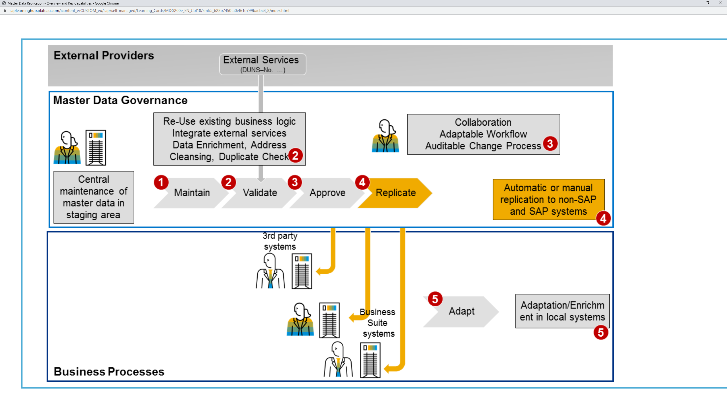

## Business Scenario.

You are an end user and need to determine within MDG HUB details about numbers of certain master data objects. You are also responsible for replications of Master Data Objects. You will perform replication for material based IDOC.

## Configuring the technical settings

First, we want to set the system, so it is capable of an IDOC replication. To do this we will change the replication from Key Replication to – Harmonised ID’s. This essentially means that the other system will have the same business object ID of what we want to replicate, so key mapping is not necessary.

|  |  |
| --- | --- |
| From the SAP easy Access Menu Open transaction DRFIMG  DRFIMG – this is mdg cofig necessary to send information from on system to another.  Here we will open  Data Replication 🡪  Define custom settings for data replication 🡪  Define Technical settings 🡪  Define technical settings for business systems. |  |
| On this screen we can see the various business systems.  The system we are currently using is T41CLNT400.  We want to replicate our material to a client system which is T41CLNT401.  Select our system T41CLNT400 then choose the 2nd folder on the left define Bus Systems |  |
| On the new screen we must choose the business object type.  Now this is in reference to specific business object types you will be communicating such as BP, MM etc.  We choose 194 as that is the BO type for MATERIAL. Select 194  Then choose the third folder on the left column as show. |  |
| Now here is where we want to change the values of the replication. The channel represents the different methods of replication in our case IDOC is Important to us.  We need change the values from Key mapping to Harmonized IDs. |  |
| We need to repeat the steps as previous and change the values to Harmonized IDs for the external client system. |  |

## Creating a material.

Now we will create our own very simplified material through NWBC that will be used in our replication

|  |  |
| --- | --- |
| Start by opening NWBC menu through transaction nwbc.  Select Search Material, This is the safest way to create material as it is always important to check if the material already exists to not make a duplicate. |  |
| Search for the material you will be creating in our case I searched for  T-MDGM01-REPL.  Click search, no results should appear.. Click new to create the material |  |
| Make sure to choose the correct change request type.   In our case it is the first one MAT01 ie Create Material. |  |
| Fill in the details as shown in the image to the right.  Additionally to this be sure to fill in a description for the material.  Eg: Replication to Client System.  Submit your material. Once submitted refresh your screen and activate your material.   Your material is now created and ready for replicaiton |  |

## Replicating a Material

In the following steps you will initiate a manual replication of your material to an external T41 client 401 system.

|  |  |
| --- | --- |
| There are two ways to replicate a material through NWBC  We can ‘Choose Replicate material by selection’ highlighted on the screen  Or we can search the material as before and choose the replicate option.  Neither have an advantage or disadvantage it’s a total preferential choice which you do.  In this case we will search the material |  |
| Search the material we just created ‘T-MDGM01-REPL’  The select the material and choose replicate as highlighted in the picture shown. |  |
| On the new screen you will see our Material.  You can also see Material Object Type: Product if you remember this is the 194 we changed at the beginning.  Select the target system on the right ‘T41CLNT401’  As stated earlier this is the external client system we are replicating the material to.  Choose replicate in the bottom right corner. |  |
| On the bottom of the screen you should get a notification stating the replication of the selected object.  This means the replication has started correctly |  |

## Checking the Replication Status

We will now check the replication status of our material/IDoc

|  |  |
| --- | --- |
| First we check the replication logs.  Choose the view logs button in the top left corner to view the replication logs.  Here you can see the logs of your replication..  Take note of your idoc number in this case it is 111004 highlighted in our picture |  |

|  |  |
| --- | --- |
| We can now check the status of our IDoc.  First return to the SAP Easy Access Menu and search Transaction BD87.  Now enter your IDOC number  In our case 11104  Choose execute |  |
| You will now see the ALE Messages for our replication. We can see the data passed to the client system okay.  To view a more detailed status double click on the MATMAS |  |
| You should now see a more detailed selection.  Again you will see the status 03. This means it has been successfully replicated.  You can also see status text  ‘IDoc sent to SAP system or external program’ |  |
| There is a secondary method to view your IDOC replication status. Return to the Easy Access Menu and enter transaction we02  Like Before input your IDOC number and choose execute |  |
| Here we can see a record of the status  01 IDoc created  30 IDoc ready for dispatch  03 Data passed to port ok  On the right you can also see the direction stating the idoc Is out bound.  Again we can see current status 03, and the port is T41CLNT401 representing the external client system. |  |

## Signing into the client System

We now have seen the status and how our IDoc was replicated successfully to an external/ client system. We can now log into that client system and see the process of the IDoc on that side.

|  |  |
| --- | --- |
| First thing we need to do is log on to the client site.  To do this we need to return to the Easy Access menu and search transaction SM59.  Open the Folder ABAP Connections and search for the client system T41CLNT401  Double click to open |  |
| On this screen you can see the details of the client system.  Choose Remote logon in the top left corner highlighted. |  |
| On the new system repeat as you did before.  Return to the EasyAccess menu and search transaction BD87.    Here you can see the difference:  It says ‘IDoc in inbound processing’ suggesting the IDoc is incoming rather than the previous outgoing.  We also see the status is 53, which means the document has been posted |  |
| Again checking the alternative transaction like before WE02.  We can see the status records is different:  50 IDoc added  64 IDoc Ready to be passed to application  62 IDoc passed to application  53 Application document Posted  Application posted essentially means the Material has been created |  |
| Returning to the Easy Access Menu  Search transaction MM03  The input the details of the material we created and replicated.  Choose select View and select all then choose execute |  |
| The material we originally created in the other system will open highlighting a successful replication to the external client system |  |

